Project Design Phase-II
Technology Stack (Architecture & Stack)
Date | 3 october 2026
Team ID | [SWTID-2026-8414]
Project Name | Auto Ticket Classification using Flow Designer in Skill Wallet – ServiceNow Course
Maximum Marks | 4 Marks

Technical Architecture:
The deliverable shall include the architectural diagram below and the technology-stack information for the Skill Wallet ServiceNow solution.
Example: Automated ticket classification and routing using ServiceNow Flow Designer.
Reference: ServiceNow – Flow Designer documentation
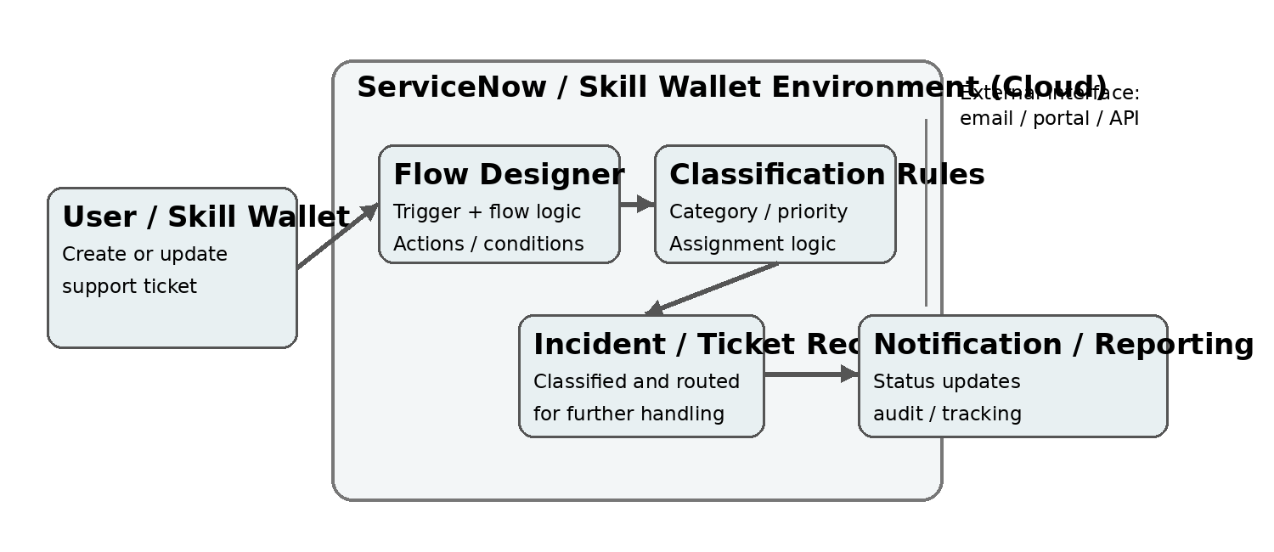 | Guidelines:  • Include all application processes as Flow Designer logic / technology blocks.  • Show the ServiceNow cloud boundary and external interfaces such as portal, email or APIs.  • Indicate data storage components, including Incident/Ticket records and platform data.  • Show trigger, condition, classification rule and action steps in the workflow.  • Indicate notification and reporting outputs after classification.  • Mention testing and validation of classification rules and flow execution.  • Technology stack: ServiceNow Platform, Skill Wallet, Flow Designer, Incident Management, business rules/conditions and platform data.

